# Technical Writing Example

## Memo

Date: May 15th, 2015   
To: Mike Bennett   
From: Web Developer (Your Name)   
RE: WEBSITE PROJECT REPORT UPDATE

## **Opening**

Mike, here is a report outlining the progress on the development of your new company website. This memo includes a general overview of the new website project and a review of the navigational and design topics we have previously discussed. Also, I have provided details about the progress I have made on the website. The last part of the report presents a proposed tentative outline for the final report.

## Introduction

**Project Overview (Body)**

**Subject.** This project focuses on the development of a new company website for Hamilton's Refrigerating, Heating and Air.

**Purpose.** The purpose of the project is to develop the website using input from the customer and ongoing communication between the other project team members.

## Progress Overview

You have returned the client checklist. Now the team can move forward in the planning stage and address other items on the checklist. I am on target to meet the planning stage deadline of June 15. Next our team will move to the design phase. We should be ready to begin that phase in about four weeks.

There are four main phases for this project:

1. Planning
2. Design
3. Development
4. Launching the Site and Testing

We are about half way through the first phase of the project. Next week, I will start working on a navigational layout for the site.

The planning phase of the project is very important so I will continue working with our team and communicating with you to make sure we are on the same page.

## Planning Phase Progress

*Work Completed.* Upon receiving the client checklist, our project team met to go over the document. Each team member was assigned a role in the project and given a set of milestones to complete. During the planning stage, each team member will create a wireframe prototype to help prepare for the next stage of the process. Wireframe phototypes are hand-drawn or computer-generated sketches of the entire site. See the example below.

. 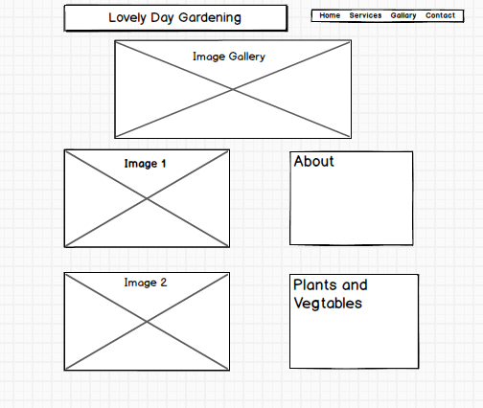

After the wireframes are complete, the team will meet again to examine each prototype. It should take the team at least one week to prepare the wireframe examples. I will be managing this project and using Microsoft Project to track all milestones and deadlines. I will be sending a progress report to you and all of the team members every two weeks. Toward the end of the project, I will create a report outlining each stage of the website development project. See the outline of the final report I intend to produce on the next page.

## Report Outline

1. Opening
2. Introduction
3. Body
4. Planning
   1. Item 1
   2. Item 2
5. Design
   1. Item 1
   2. Item 2
6. Development
   1. Item 1
   2. Item 2
7. Launching the site
   1. Item 1
   2. Item 2
8. Conclusion

## Conclusion

At this time, everything is working according to schedule and we have not encountered any problems. If you wish to see any of the actual wireframes after they are completed, please let me know. Our team welcomes any suggestions or concerns you might have.

Regards,

Your Name